**WEB TECHNOLOGY WITH UI UX**

**ASSIGNMENT 1 – TASK1**

**NAME: BHAKTI SARVAIYA ROLLNO: 59**

**CLASS: 4CSE_E BRANCH: CSE**

**STEP 1 – Click on new button to create a new repository**

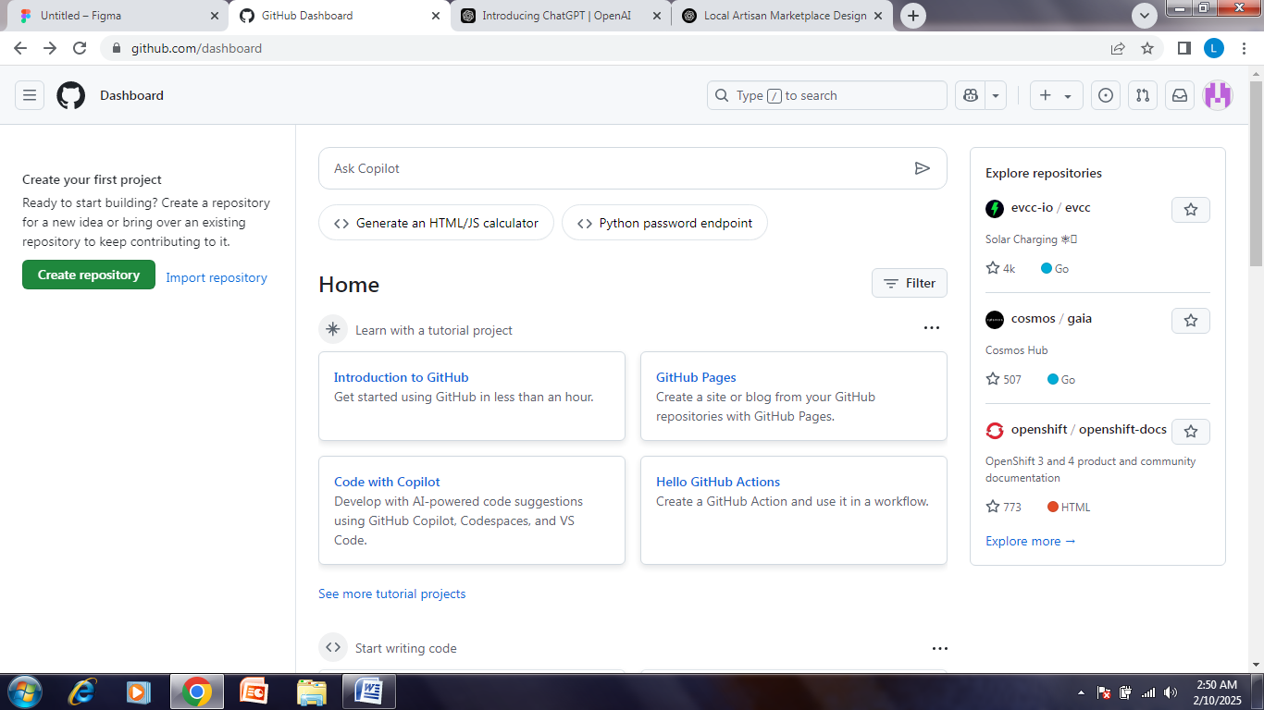

**STEP 2 – In the Repository name field, enter repo name**



**STEP 3 – click “Create repository”** 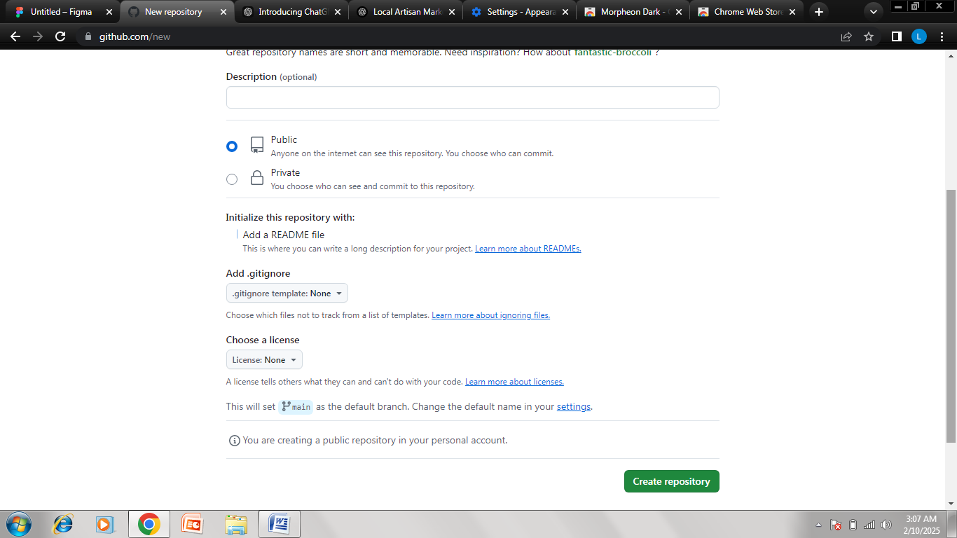

**STEP 4 – Click the “Add file” dropdown, select “Create new file”**

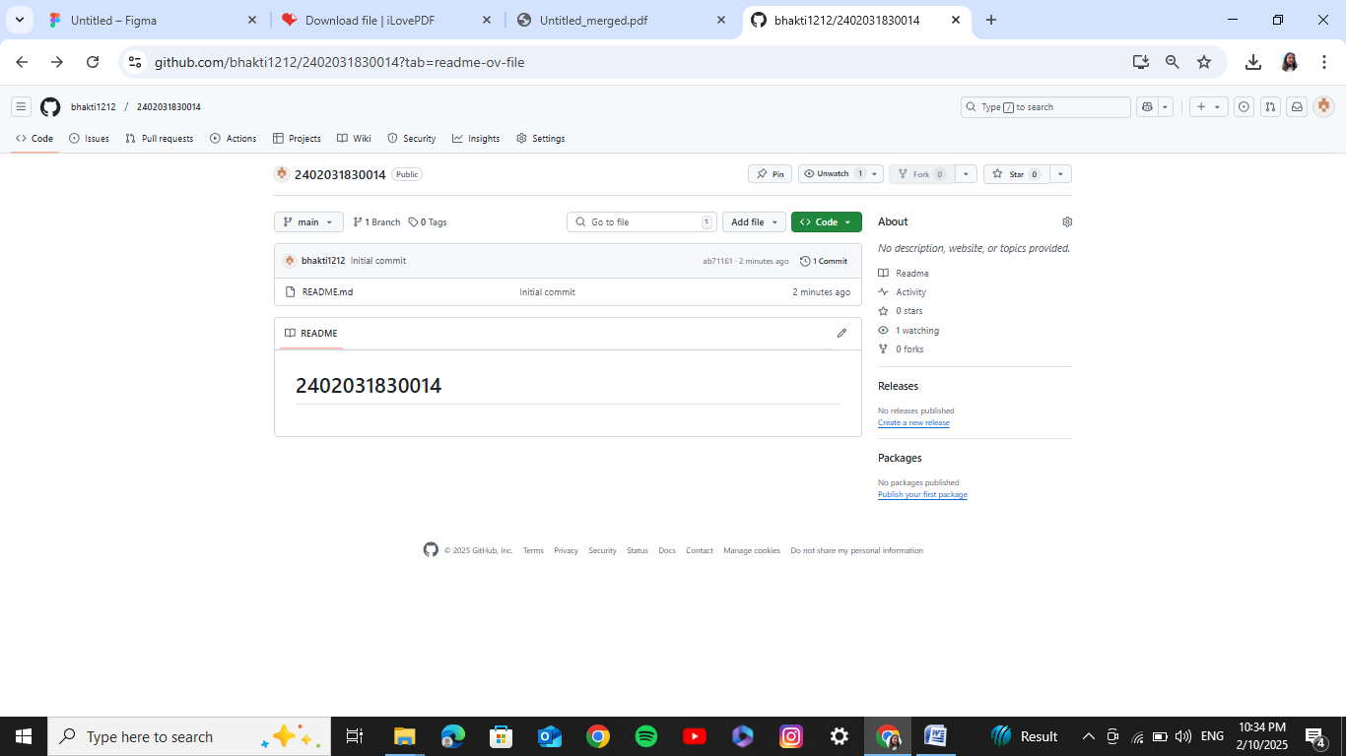

**STEP 5 – Type the folder name followed by a slash (/) to create the folder structure and click on commit changes**

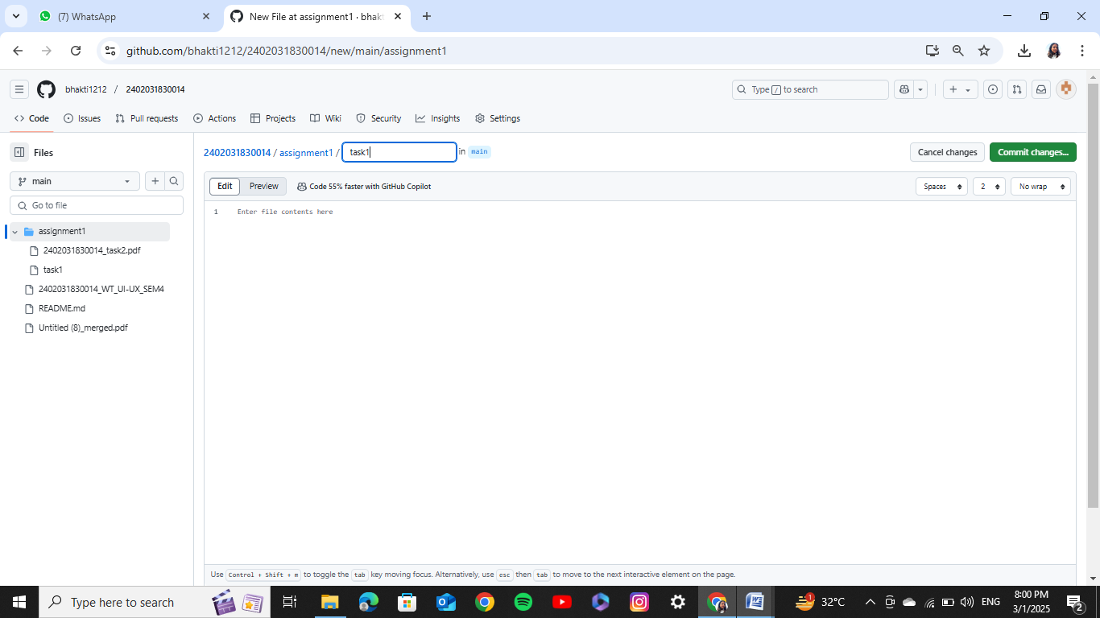

**STEP 6 – Assignment 1 folder created**

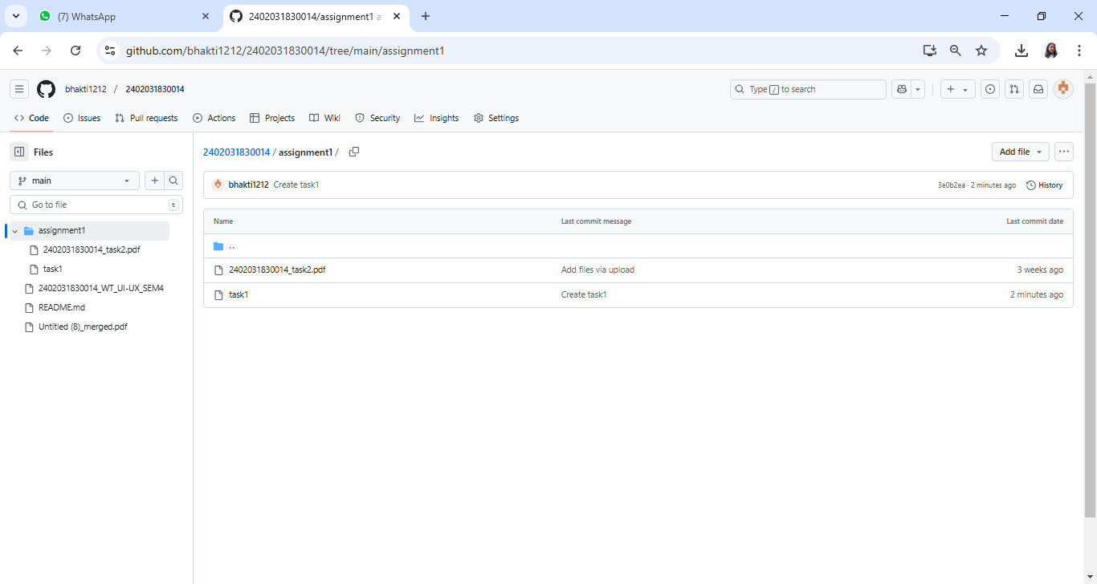

**STEP 7 – Add the file into the assignment 1 folder**

